Officials, Veterans Urge Careful Consideration for MDMA-Assisted Psychotherapy
August 8, 2024
By Heidi Anne Duerr, MPH
News
Article
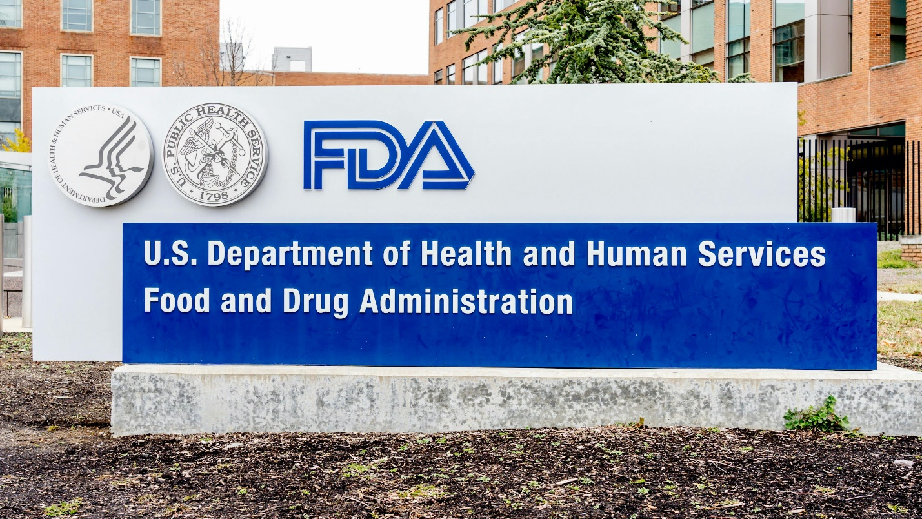
JHVEPhoto/Adobestock
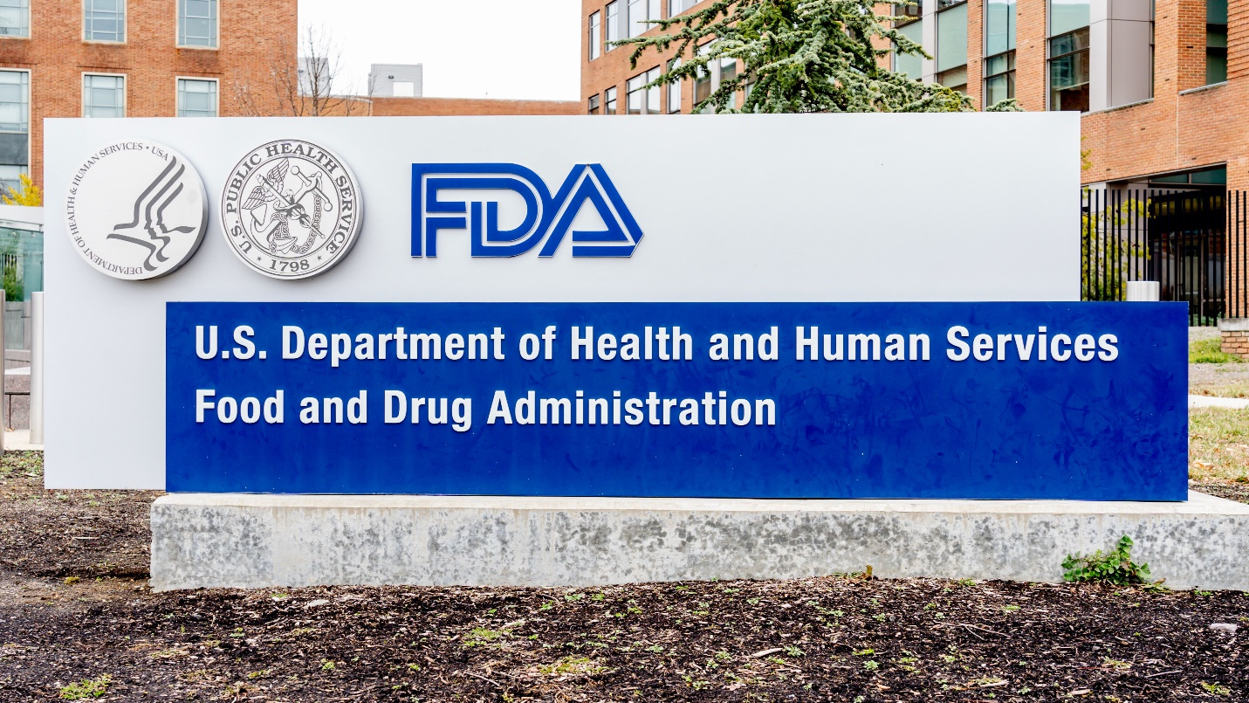
With the US Food and Drug Administration scheduled to review and share a decision on the use of MDMA-assisted therapy for treating posttraumatic stress disorder (PTSD) this week, pressure has been rising to support those diagnosed with this disorder, especially veterans.
Earlier this week, 730 first responders and veterans submitted a letter to President Joe Biden, Vice President Kamala Harris, Secretary of Health and Human Services Xavier Becerra, Secretary of Veterans Affairs Dennis McDonough, and Commissioner of Food and Drugs for the FDA Robert Califf, MD, urging support for the approval.
“PTSD is one of the few psychiatric disorders that reliably predicts suicidal ideation, suicide attempts, and suicide mortality, significantly contributing to our nation's veteran suicide epidemic, which claims between 17 and 44 veteran lives daily,” they wrote on August 4, 2024. “Since 9/11, nearly 150,000 veteran lives have been lost to suicide-21 times the number of US service members lost in post-9/11 warzones.”
The letter further noted that current treatments inadequately address PTSD symptoms, while “Phase Three clinical trials of MDMA-AT resulted in 71% of participants no longer qualifying for a PTSD diagnosis and 86% of participants experiencing ‘clinically significant’ improvement in their symptoms.”
Similarly, 60 members of Congress led by Representative Jack Bergman (MI-01) appealed to President Biden on August 2, 2024, “to express our sense of urgency to address the post-traumatic stress disorder (PTSD) and suicide epidemic among Veterans and servicemembers, and the grave need for new and better treatment options like MDMA-assisted therapy.”
Specifically, the elected officials noted the potential for bias to have entered the discussion on the value and merit of MDMA-assisted psychotherapy:
“It is not our intent to urge the FDA in any direction related to its decision, which must be based solely on the data and evidence. However, we are aware that as this application has made its way through the regulatory review process, certain groups and individuals have voiced criticism of the application. It is our understanding that while these critics may be well-intentioned, their criticism is not necessarily reflective of the science, but rather their personal ideological beliefs and biases related to the medicalization of substances like MDMA,” they wrote.
“While all Americans are free to voice their views on this and other topics of public interest, scientific evidence should not be ignored in favor of those who have been on a mission to discredit this promising treatment at all costs – especially when that would come at the cost of our servicemembers and Veterans,” they added.
US Senators led by Michael F. Bennet (Colorado) sent an appeal to FDA Commissioner Califf on August 5, 2024. “Advancements in scientific research offer new hope for those suffering from PTSD; MDMA-AT is one of the most promising and available options to provide reprieve for veterans’ endless PTSD cycle, which the FDA recognized in 2017 when they designated MDMA-AT as a Breakthrough Therapy,” they wrote.
“The potential for groundbreaking advancements in PTSD treatment is within reach, and we owe it to our veterans and other affected populations to review these potentially transformative therapies based on robust clinical and scientific evidence,” the senators added. “The FDA is internationally recognized as the gold standard for drug safety and efficacy review, and we urge the Agency to continue upholding this rigorous standard of safety, quality, and effectiveness, especially for therapies targeting conditions like PTSD, which is alarmingly prevalent among our nation's veterans.”
There has been much excitement and discussion over MDMA-assisted psychotherapy for numerous reasons. For one, there has not been an approval for treating PTSD in the last 20 years, and the options to treat the disorder are limited. It also touches upon the issue of psychedelics as potential prescribed medications for a variety of psychiatric disorders.
Last month the FDA Psychopharmacologic Drugs Advisory Committee voted overwhelmingly against recommending approval, although the committee does not make the final decision.¹ Their vote came after a full day of testimony, often emotional, from patients, civilians, clinicians, and others commenting on the treatment, the studies, and the impact of PTSD. The committee was also presented with data from the studies leading to submittal for FDA consideration, including issues regarding safety and efficacy.
After learning of the decision, Psychiatric Times editor in chief, John J. Miller, MD, expressed some disappointment, noting with only 2 drugs approved to treat PTSD, there is a huge unmet need in this patient population. "This is uncharted territory for us in psychiatry and for the FDA,” he added in an interview with Psychiatric Times. “It's an exciting time, and there is a lot of promise moving forward in medication-assisted psychotherapy."
At that time, Amy Emerson, the CEO of Lykos Therapeutics, told the press, “We are advancing a novel treatment and have worked closely with the FDA over the course of years to address these complex issues...We have full confidence in the rigor and thoughtfulness that the FDA will give our application.”²
For continued coverage and updates on this story and all else that matters in psychiatry, follow Psychiatric Times on social media and subscribe to our e-newsletters.

